**Lecture-3**

# **DBMS Architecture**

* The DBMS design depends upon its architecture. The basic client/server architecture is used to deal with a large number of PCs, web servers, database servers and other components that are connected with networks.
* The client/server architecture consists of many PCs and a workstation which are connected via the network.
* DBMS architecture depends upon how users are connected to the database to get their request done.

## Types of DBMS Architecture

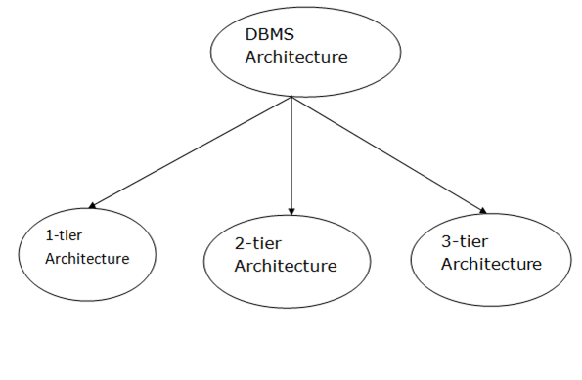

Database architecture can be seen as a single tier or multi-tier. But logically, database architecture is of two types like: **2-tier architecture** and **3-tier architecture**.

### **1-Tier Architecture**

* In this architecture, the database is directly available to the user. It means the user can directly sit on the DBMS and uses it.
* Any changes done here will directly be done on the database itself. It doesn't provide a handy tool for end users.
* The 1-Tier architecture is used for development of the local application, where programmers can directly communicate with the database for the quick response.

### **2-Tier Architecture**

* The 2-Tier architecture is same as basic client-server. In the two-tier architecture, applications on the client end can directly communicate with the database at the server side. For this interaction, API's like: **ODBC**, **JDBC** are used.
* The user interfaces and application programs are run on the client-side.
* The server side is responsible to provide the functionalities like: query processing and transaction management.
* To communicate with the DBMS, client-side application establishes a connection with the server side.

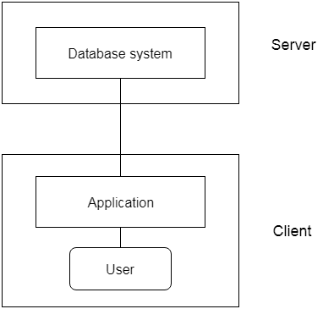

**Fig: 2-tier Architecture**

### **3-Tier Architecture**

* The 3-Tier architecture contains another layer between the client and server. In this architecture, client can't directly communicate with the server.
* The application on the client-end interacts with an application server which further communicates with the database system.
* End user has no idea about the existence of the database beyond the application server. The database also has no idea about any other user beyond the application.
* The 3-Tier architecture is used in case of large web application.

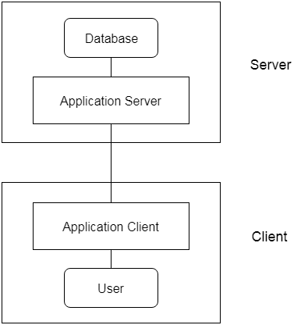

**Fig: 3-tier Architecture**

**OR**

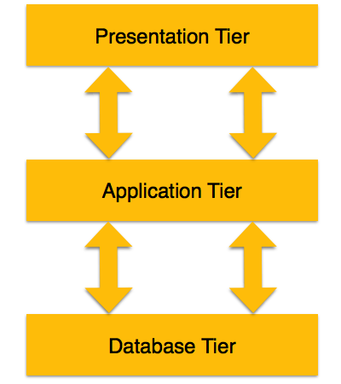

* **Database (Data) Tier** − At this tier, the database resides along with its query processing languages. We also have the relations that define the data and their constraints at this level.
* **Application (Middle) Tier** − At this tier reside the application server and the programs that access the database. For a user, this application tier presents an abstracted view of the database. End-users are unaware of any existence of the database beyond the application. At the other end, the database tier is not aware of any other user beyond the application tier. Hence, the application layer sits in the middle and acts as a mediator between the end-user and the database.
* **User (Presentation) Tier** − End-users operate on this tier and they know nothing about any existence of the database beyond this layer. At this layer, multiple views of the database can be provided by the application. All views are generated by applications that reside in the application tier.

Multiple-tier database architecture is highly modifiable, as almost all its components are independent and can be changed independently.